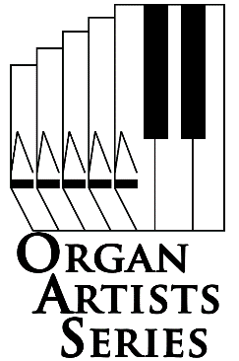Join the Organ Artists Series (OAS)

for our 38th season of fine organ  
music in Pittsburgh.

*Hear the organ like you've  
never heard it before!*

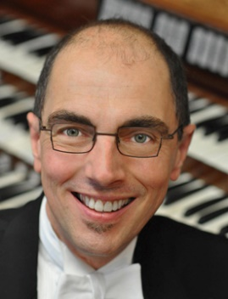

|  |
| --- |
| **Sunday October 16, 2016 3:00 pm**  East Liberty Presbyterian Church *116 South Highland Avenue , Pittsburgh 15206-3911* Aeolian Skinner , Opus 884  Presented in cooperation with***Cathedral Concerts at East Liberty Presbyterian Church***  **David Higgs** Chair of the Organ Department Eastman School of Music |

|  |
| --- |
| **Friday November 18, 2016 8:00 pm**  Heinz Memorial Chapel *Fifth and Bellefield Avenue, Pittsburgh, PA 15260-1212* Reuter, Opus 2176  Presented in memory of University of Pittsburgh Organist***Dr. Robert Sutherland Lord***  **Chelsea Chen** Concert Organist and Composer Coral Ridge Presbyterian Church, Fort Lauderdale, Florida Artist-in-Residence at Emmanuel Presbyterian Church, New York, New York |

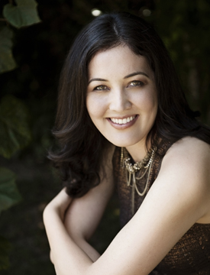

|  |
| --- |
| **Friday, February 17 , 2017 8:00 pm**  Saint Paul Cathedral *108 North Dithridge Street, Pittsburgh, PA 15213-2608 von Beckerath, 1962 & 2009*  Co-presented with Saint Paul Cathedral Concert Series.  **Carole Terry** Professor of Organ and Harpsicord University of Washington School of Music |

|  |
| --- |
| **Sunday April 23, 2017 3:00 pm**  Shadyside Presbyterian Church *5121 Westminster Place, Pittsburgh, PA 15232-2164* Reuter, Opus 2729  Presented in cooperation with***Music In A Great Space***  **Martin Jean** Professor of Organ at the Yale School of Music Director of the Yale Institute of Sacred Music |

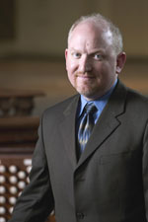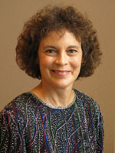

Regular admission $12, student free with ID.  
Season tickets $36, student free with ID.

Concerts typically include a brief intermission and  
last about 1½ hours. A reception follows the afternoon   
performances with some light refreshments and  
hors d'oeuvres (shrimp, cheese, etc.).

**WWW.OAS-SERIES.COM**

412-242-2787 (arts) email: **info@oas-series.com  
© 2016, Organ Artists Series**