**THE ORGAN ARTISTS SERIES OF PITTSBURGH**

**presents**

**Martin Jean**

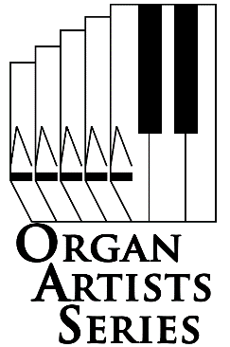*Professor of Organ at the Yale School of Music  
Director of the Yale Institute of Sacred Music  
  
 Presented in cooperation with* ***Music In a Great Space*** **Sunday April 23, 2017 3:00 pm**

**Shadyside Presbyterian Church** 15121 Westminster Place, Pittsburgh, PA 15232-2164

*Martin Jean has risen to the highest ranks of the world's concert organists and is recognized widely as a brilliant, warmly communicative artist and readily appealing personality. As the winner of two of the most prestigious organ competitions in the world, he has concertized extensively throughout the United States, Canada and Europe.*

*In 1986 Martin Jean was awarded first prize at the international Grand Prix de Chartres competition, held bi-annually at the Chartres Cathedral, France. As part of this prize, he was invited several times for concert tours of France, England and Luxembourg, where he played at the cathedrals of Poitiers, Chartres, Orléans, Chichester, Oxford and St. Alban's. He also appeared in concert at Radio France in Paris as part of a recital series commemorating the 50th anniversary of the death of Louis Vierne, a performance which was broadcast live over much of western Europe. A testament to the respect which he has earned in France because of his win there, he has been invited by the competition's board of directors to be one of the judges for the 1998 Chartres competition. He was a featured performer at the 2004 national convention of the American Guild of Organists held in Los Angeles and will be at the organizations' 2006 national convention in Chicago.*

*Join us for organ like you've never heard it before!*

**Doors open 30 minutes before performance.**

**Adults, $12. Students, free with ID.**

**Tickets are available at the door**

**Call 412-242-2787 (arts)**.

**www.oas-series.com**

2016 Organ Artists Series of Pittsburgh, All rights reserved