**THE ORGAN ARTISTS SERIES OF PITTSBURGH**

**presents**

**Carole Terry**

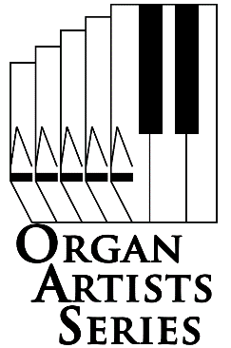*Professor of Organ and Harpsicord  
University of Washington School of Music*

*Co-presented with Saint Paul Cathedral Concert Series* **Friday February 17, 2017 8:00 pm**

**Saint Paul Cathedral** 108 North Dithridge Street, Pittsburgh, PA 15213-2608

*Carole Terry’s career has taken her to many cities and universities throughout the United States, as well as Europe and the Far East. Especially known for her performances and recordings of German Romantic music, she is also an expert on the physiology of keyboard performance. She attended Southern Methodist University, Eastman School of Music and Stanford University.*

*She has appeared at festivals and academies in Manila, Lübeck, Oundle, Calgary and Montreal. She has also adjudicated major competitions in Japan, Russia and the United States. In 2004 she was the first American organist to perform in the organ concert hall of Perm, in the Russian Federation.*

*In the United Sates she has performed in a variety of conventions for the American Guild of Organists. In addition, she has participated as a performer and lecturer for major conferences such as the Westfield Center for Early Keyboard Studies. As Resident Organist and Curator for the Seattle Symphony, from 2000 to 2003, she inaugurated the new C.B. Fisk organ in Seattle’s acclaimed Benaroya Hall, and played many solo concerti in addition to monumental works for organ and orchestra.*

*Join us for organ like you've never heard it before!*

**Doors open 30 minutes before performance.**

**Adults, $12. Students, free with ID.**

**Tickets are available at the door**

**Call 412-242-2787 (arts)**.

**www.oas-series.com**

2016 Organ Artists Series of Pittsburgh, All rights reserved