**THE ORGAN ARTISTS SERIES OF PITTSBURGH**

**Presents**

**Chelsea Chen**

*Concert Organist and Composer*

*Coral Ridge Presbyterian Church, Fort Lauderdale, Florida*

*Artist-in-Residence*

*Emmanuel Presbyterian Church, New York, New York*

*Presented in memory of University of Pittsburgh Organist*

*Dr. Robert Sutherland Lord*

**Friday November 18, 2016 8:00 pm**

**Heinz Memorial Chapel**

Fifth and Bellefield Avenue, Pittsburgh, PA 15260-1212

*One Organist and composer Chelsea Chen, born in 1983, is internationally renowned for her concerts of “rare musicality” and “lovely lyrical grandeur,” and a compositional style that is “charming” and “irresistible” (Los Angeles Times).*

*Chelsea Chen has electrified audiences throughout the United States, Europe, Australia, and Asia in venues such as Singapore’s Esplanade, Hong Kong’s Cultural Centre, Kishinev’s National Organ Hall, and Philadelphia’s Kimmel Center. As a composer she is broadening the classical organ repertoire with her own works based on Asian folksongs.*

*Ms. Chen has soloed with orchestras throughout the world including the Wuhan Philharmonic in China, the Jakarta Simfonia in Indonesia, and the Juilliard Percussion Orchestra in Lincoln Center’s Alice Tully Hall. She has additionally performed under the baton of eminent conductors such as Jahja Ling, JoAnn Falletta, and Victor Yampolsky. Committed to new music, she has premiered works by composers throughout the world including Ola Gjeilo (Norway/USA), Yui Kitamura (Japan/USA), Paul Desenne (Venezuela), Roderick Gorby (USA), and Andreas Kleinert (Germany).*

**Join us for organ like you've never heard it before**!

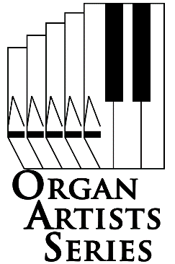

Doors open 30 minutes before performance.

Adults, $12. Students, free with ID.

Tickets are available at the door

Call 412-242-2787 (arts).

**www.oas-series.com**

© 2016 Organ Artists Series of Pittsburgh, All rights reserved