**THE ORGAN ARTISTS SERIES OF PITTSBURGH**

**presents**

**David Higgs**

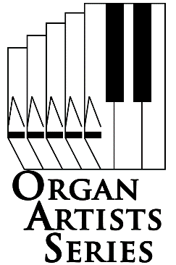*Chair of the Organ Department  
Eastman School of Music*

*Presented in cooperation with*

*Cathedral Concerts at East Liberty Presbyterian Church*

**Sunday October 16, 2016 3:00 pm**

**East Liberty Presbyterian Church** 116 South Highland Avenue , Pittsburgh 15206-3911

*One of America’s leading concert organists, David Higgs is also Chair of the Organ Department at the Eastman School of Music. He performs extensively throughout the United States and abroad, and has inaugurated many important new instruments including St. Stephan’s Cathedral, Vienna; the Meyerson Symphony Center, Dallas; St. Albans Cathedral, England; St. Canice’s Cathedral, Kilkenny, Ireland; and the Church of St. Ignatius Loyola in New York City. His performances with numerous ensembles have included the Chamber Music Society of Lincoln Center, the Orpheus Ensemble, Chanticleer, and the Empire Brass. For more than twenty years the San Francisco Symphony featured his holiday organ recitals at Davies Symphony Hall, and now the Los Angeles Philharmonic/Hollywood Bowl continues that tradition each year at the Walt Disney Concert Hall.*

*In addition to his significant performing career, Mr. Higgs has distinguished himself as a pedagogue. He was appointed to the faculty of the Manhattan School of Music upon graduation from that institution, and has been a member of the faculty of the Eastman School of Music since 1992. His students have won prizes in prestigious international competitions, and hold important positions in leading academic and religious institutions.*

*Join us for organ like you've never heard it before!*

**Doors open 30 minutes before performance.**

**Adults, $12. Students, free with ID.**

**Tickets are available at the door**

**Call 412-242-2787 (arts)**.

**www.oas-series.com**

2016 Organ Artists Series of Pittsburgh, All rights reserved